Top 13 Outdoor Security Systems
Not at home and worrying about the security? Or setting up a cafe, restaurant or any shop and worrying about the security of customers and shop? Or just planning to go to a weekly tour but no idea about the security of your home and office? Don't worry, here are the best 13 outdoor security systems which help you to Not Worry About Outdoor Security.
There are abundance number of outdoor security cameras but what should you buy is a question, then you're at the right place for looking it. So, what are you waiting for, read the following products and choose your product which match your criteria and get free from your worry.
1. ARLO PRO 3 FLOODLIGHT OUTDOOR CAMERA
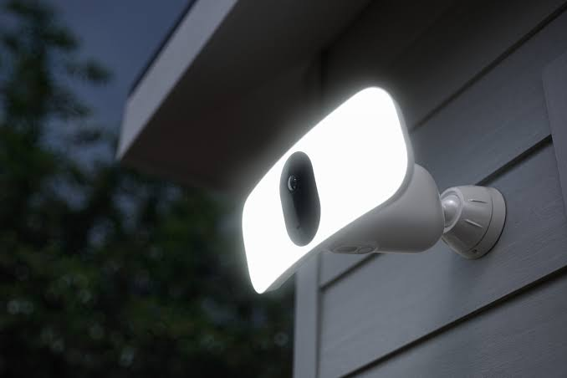
(URL of Picture : https://images.app.goo.gl/YCTca3efGtyBqcd98)
First 100% Wireless Outdoor Camera which illuminates the darker to darkest area also. It has a Motion Activated Light which gives the light to the most vulnerable parts of the security area. The Camera a sharp HD live - streaming which delivers speedy alerts by offering you the true security features with alarming and dis - alarming features. Giving you the 2K resolution. Also works with the Alexa and the Google Assistant, too. It is giving you the motion-sensor feature as the camera is armed, the motion - sensor activates and the floodlight will be on by itself.
Key Features
- Easy Installation
- Color Night Vision
- 6 month Battery Life
Link to buy from Amazon.com : https://www.amazon.com/Arlo-Floodlight-Wire-Free-6-Month-Activated/dp/B084TTKWHM
2. ARLO ULTRA OUTDOOR CAMERA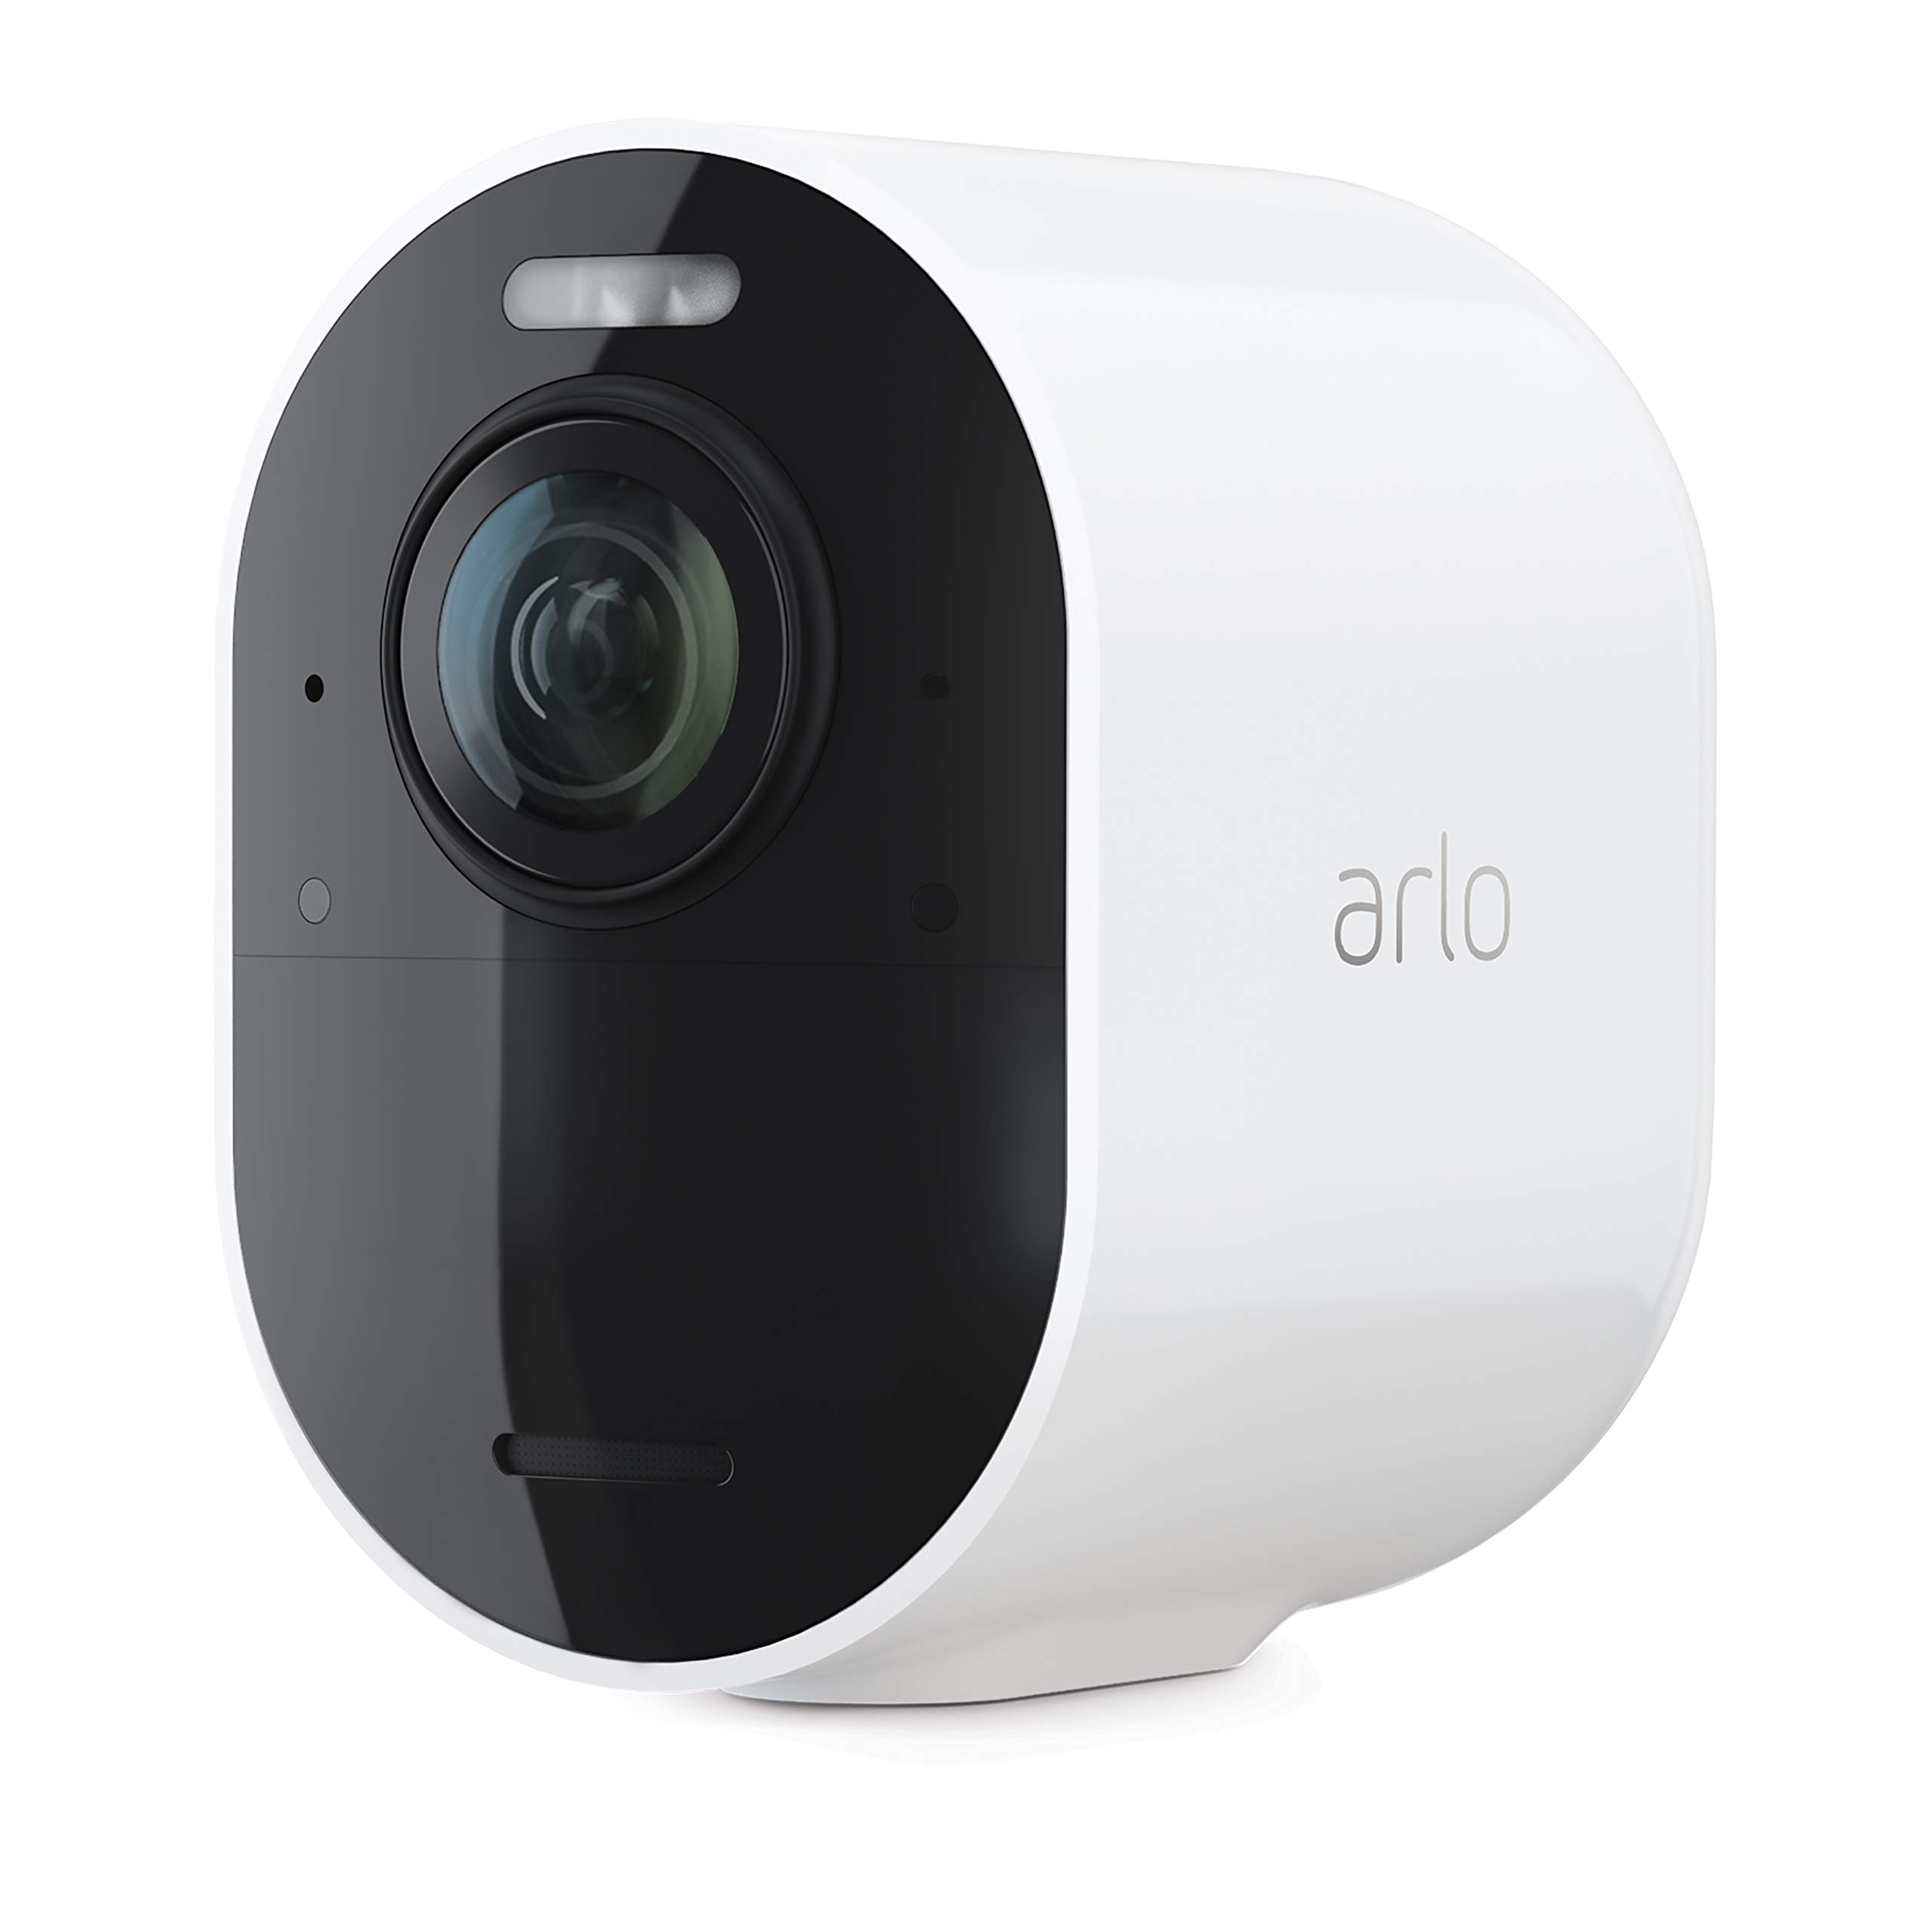
(URL of Picture : https://images.app.goo.gl/cxVU8Whm1sNB8XBE7)
First Outdoor Security Camera which provides the live - streaming video in 4K. Arlo Ultra camera is larger than Arlo Pro 2. Including the camera, there is a Base Station (SmartHub), battery pack, a USB charger and a charging cable, a magnetic mount, a mounting arm and mounting hardware.
Key Features
- Camera is 4K
- Auto Zooming
- Intelligent Motion Detection
Link to buy from Amazon.com : https://www.amazon.com/Arlo-Spotlight-Wire-
Free-Separately-VMC5040-200NAS/dp/B08HRLQ9ZG
3.EZVIZ C3W Security Camera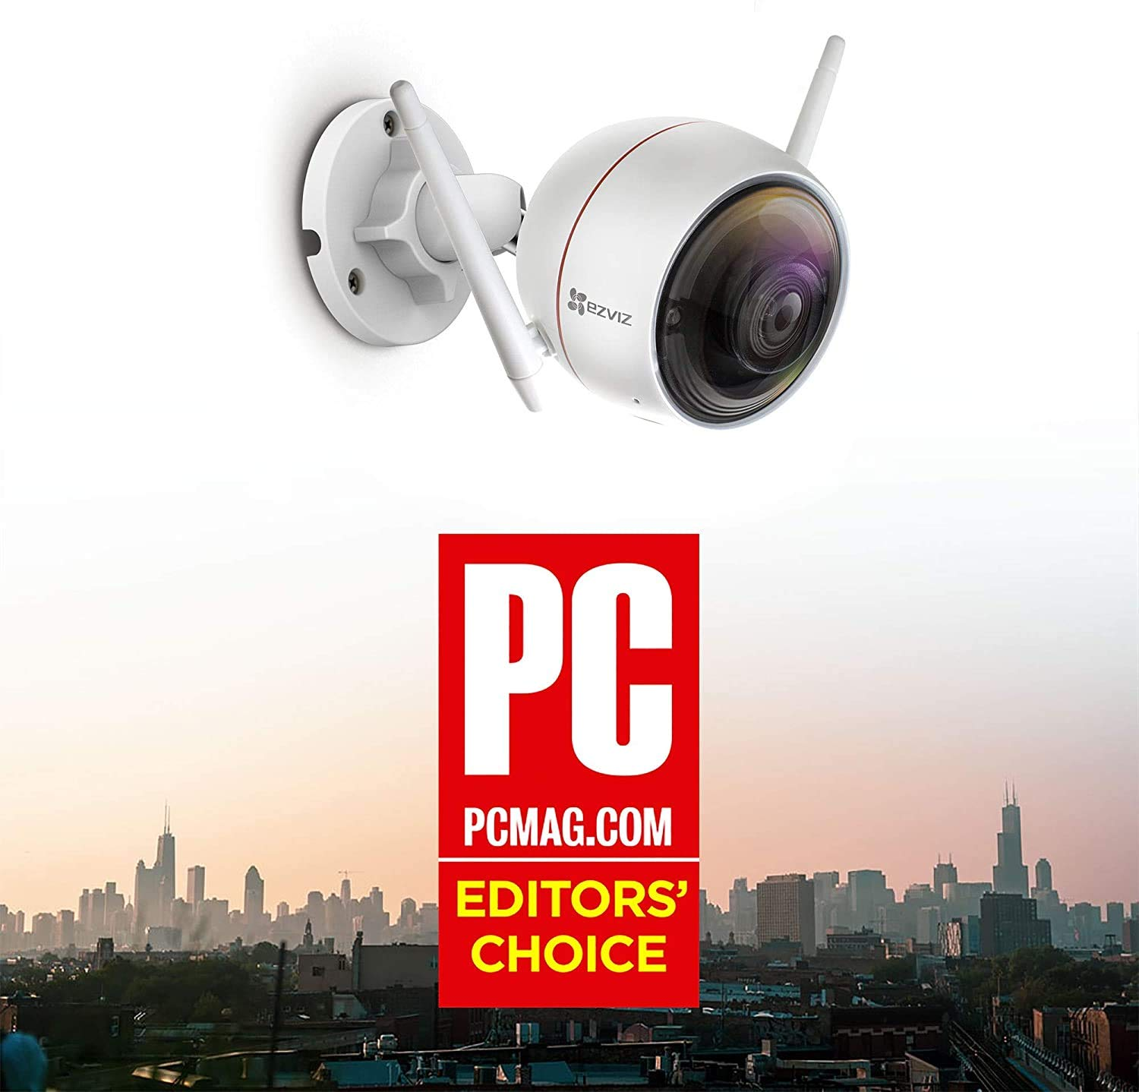
(URL of Picture : https://www.amazon.com/dp/B079D8CTWJ/ref=cm_sw_r_cp_awdb_imm_t1_4fQbGb3FWZ0A7)
This cylindrical camera is 3.3 inches long by 2.8 inches wide with the adjacent 360 degree swivel mounting base which makes the total length of 5.9inches.The C3W Camera comes along a weatherproofing shield for the power connection, mounting hardware, a drilling template for the base with the start guide.
Key Features
- Very Affordable Price
- Easy to Install
- Good Daylight and Night Vision
Link to buy from Amazon.com : https://www.amazon.com/EZVIZ-C3W-ezGuard-1080p-Activated/dp/B08KKTX9PY
4. Wyze Cam Pan
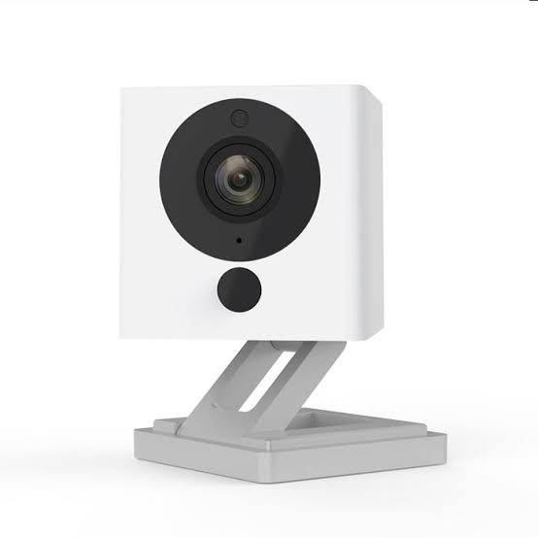
(URL of Picture : https://images.app.goo.gl/ZXrSAFFPqciW9dWK9)
Wyze Cam Pan is the water-resistant camera, battery powered Wi-Fi connection is for outdoor security system. There is a travel mode which you can use without the Internet also and helps you to look out. Can save uptown 14days recording in it. With the help of motion detection and sound detection, it gives the alerts for everytime whenever it detects.
Key Features
- Water-Resistant Camera
- Save uptown 14days recording
- Good features like Motion- Detection & Sound- Detection
Link to buy from Amazon.com : https://www.amazon.com/WYZE-Outdoor-Starter-Wire-Free-Assistant/dp/B08FFJWQY1

5.Blink Outdoor Camera
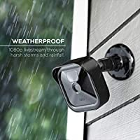
(URL of Picture : https://www.amazon.com/dp/B08M3YTKPC/ref=cm_sw_r_cp_awdb_imm_t1_SnQbGb9X039TF)
This camera offers you the good motion detection feature along the Alexa voice control amd third party smart device connections. It has a excellent feature which makes it very demanding which is Weather-Proof 1080p Camera Feature. It also provides the clouds and local storage option.
Key Features
- Battery Powered
- 1080p Weather-Proof Camera
- Cloud and Local Storage
Link to buy from Amazon.com : https://www.amazon.com/All-New-Mounting-Protective-Adjustable-Security/dp/B08M3YTKPC
6.Reolink Argus 3 Bundle with Reolink Solar Panel
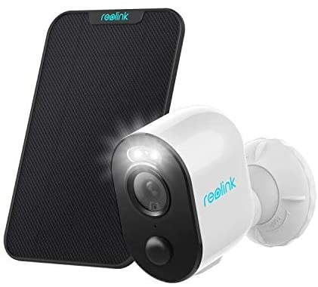
(URL of Picture : https://www.amazon.com/dp/B08SQN45J3/ref=cm_sw_r_cp_awdb_imm_t1_CoQbGb8P4RKVH)
It's an Wireless Camera with the Reolink Solar Panel which gives it the power. The best feature it provide is the night vision by it's starlight tech which makes it easier in the night to look out. It provides push notifications and email notifications with Micro-SD Card storage feature. It has a two-way audio system and also gives you multiple mounting options.
Key Features
- 1080p Video Quality
- Multiple Mounting Options
- Starlight Tech gives Clear Night Vision
Link to buy from Amazon.come : https://www.amazon.com/Spotlight-Security-Wireless-Outdoor-Wire-Free/dp/B08SQN45J3
7.Eufy Cam Pro 2
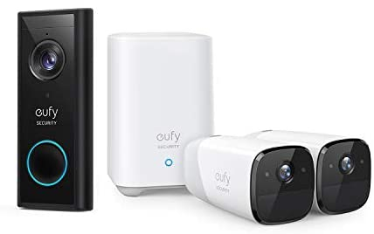
(URL of Picture : https://www.amazon.com/dp/B08C5BT5GY/ref=cm_sw_r_cp_awdb_imm_t1_FpQbGb736KBE1)
Wireless Security Camera with the 365days Battery Life. Whether you're in your pool or playing the snooker in a room and want to see who's at the front door, providing you the Homekit Compatibility with the 1080p HD Camera Quality. It also has the Eufy Security Wireless 2K Video Doorbell.
Key Features
- 1080p HD Camera Quality
- Wireless 2k Video Doorbell
- 365days Battery Life
Link to buy from Amazon.come : https://www.amazon.com/eufy-Security-Wireless-Compatibility-Doorbell/dp/B08C5BT5GY
8.Blue By ADT Outdoor Camera

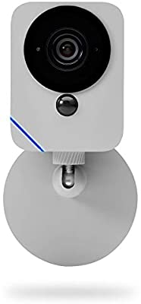
(URL of Picture : https://www.amazon.com/dp/B084ZV7V93/ref=cm_sw_r_cp_awdb_imm_t1_8qQbGbTT1DNTB)
Providing you the Two-Way Talk along the Facial Recognition Feature to you. It also has the motion- activation system. You can use it with the Wi-Fi and Alexa. Along the 1080p HD Resolution, it has the 130degree field of view and Night Vision.
Key Features
- Water-Resistant and Temperature Sensor
- 5meter (16.4 ft) Motion Detection Range
- Wireless along Rechargeable with Battery Pack
Link to buy from Amazon.come : https://www.amazon.com/Blue-ADT-Wireless-Outdoor-Camera/dp/B084ZV7V93
9.Canary Outdoor Home-Security Camera

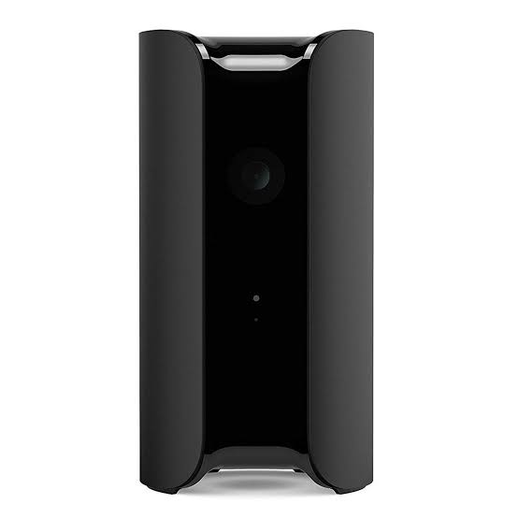
(URL of Picture : https://images.app.goo.gl/aAALKAt8op8oTYy18)
If you want to go out and worried about the Home- security, this Canary Outdoor Home Security Camera is made for you. Watch live - streaming or recorded activity of your home from anywhere anytime. So easy to setup as it has no wired or extra hubs. Data security as it has encrypted cloud storage along the secure web transfer. Supports with the AI Assistants also.
Key Features
- Encrypted Cloud Storage
- Easy to Install / Wireless without any Extra hubs
- Built in Speaker and Microphone
Link to buy from Amazon.come : https://www.amazon.com/Monitor-Premium-Security-Wide-Angle-Award-Winning/dp/B07G5H2699
10.Ring Spotlight Cam Mount

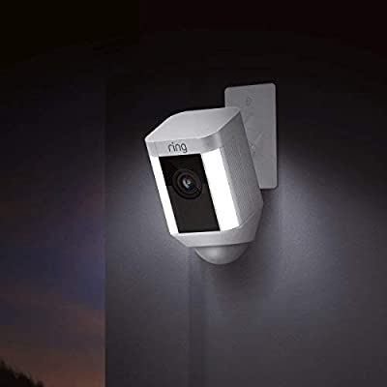
(URL of Picture : https://www.amazon.com/dp/B07YXPMBBV/ref=cm_sw_r_cp_awdb_imm_t1_ctQbGbP98Z6MJ)
Providing 1080p HD Video Quality with the ease to watch from your phone, tabs or any other device as a security. Giving you the Alerts with the Sirens and Lights Features. It has a Two- Way Talk system for better security. From Amazoz.com, it is coming with an Echo Dot also.
Key Features
- Advanced Motion Detection Feature
- Non-Stop Battery Power
- Having Ring Protect Plan
Link to buy from Amazon.com : https://www.amazon.com/Ring-Spotlight-Mount-White-Charcoal/dp/B07YXPMBBV
11. Amcret Ultra HD 4K Camera
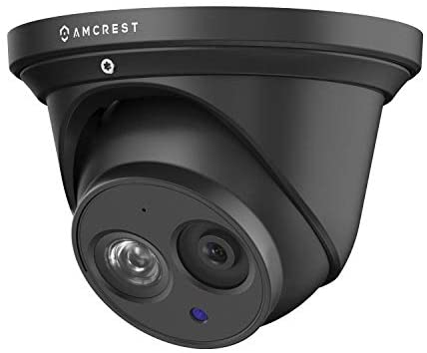
(URL of Picture : https://www.amazon.com/dp/B07Y412LYM/ref=cm_sw_r_cp_awdb_imm_t1_6tQbGbRXFQ58C)
Amcret Ultra HD 4K Camera has a Night Vision feature upto 164ft. Lens of the Camera has 360 degree Manual Pan plus 78 degree Tilt Feature. It has the Light Sensor along the One-Way Talk by Built In Microphone.
Key Features
- 4k Ultra HD Resoultion
- Giving Motion - Detection Alerts
- Night Vision Upto 164ft.
Link to buy from Amazon.com : https://www.amazon.com/Amcrest-NightVision-Weatherproof-Recording-IP8M-T2499EB-28MM-CAT5ECABLE60/dp/B07Y412LYM
12. Ring Stick Up Camera
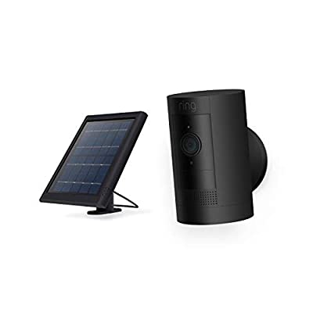
(URL of Picture : https://www.amazon.com/dp/B07W7G23ZD/ref=cm_sw_r_cp_awdb_imm_t1_wuQbGb8RN4BAE)
This Ring Stick Up Camera can get power and charge with the solar panel which comes along it. It had a 1080p HD Video Quality with the Two-Way Talk Feature. Can Watch, Save and Share the video recording as well as pictures with anyone. With the help of Given Control Center, you can add and remove authorised Clients by yourself. Can work with Alexa also.
Key Features
- Ring Protect Plan With Amazing Privacy Features
- 1080p HD Video Quality
- Have Privacy Features
Link to buy from Amazon.com : https://www.amazon.com/Staging-Product-Retail-Sale-CSB1/dp/B07W7G23ZD
13. Swann Floodlight Security Camera
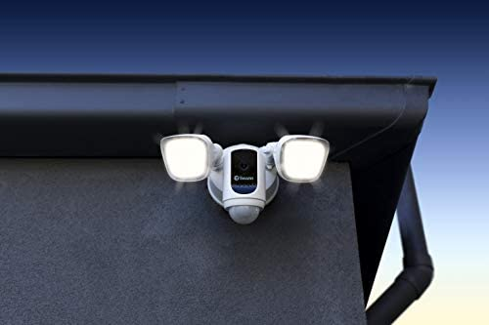
(URL of Picture : https://www.amazon.com/dp/B07QFBWSWK/ref=cm_sw_r_cp_awdb_imm_t1_ewQbGb046PEAN)
This Swann Floodlight Camera is 1080p Quality with True Heat Sensing Feature. It has the Two-Way Talk feature with the Night - Vision Capability. It keeps away the intruding strangers with its Siren and Motion - Lighting Features. With It's Super Floodlight which is 2500 lumens along the Night Vision Feature with the range covering of 100ft (30m) area.
Key Features
- 2500 lumens Floodlight
- Night Vision Upto 100ft (30m)
- Giving Notifications by detecting heat and movement
Link to buy from Amazon.com : https://www.amazon.com/Swann-Floodlight-Security-Surveillance-SWWHD-FLOCAMW/dp/B07QFBWSWK

With the help of this information, you don't need to worry for the security, just choose the best Outdoor Security System for you House, Cafe, Restaurant or For Any Surveillance Area and have a look at it.

(Research Time : 1hour 30 mins
Writing Time : 2hour 15mins
Total Time : 3hour 45mins
Written By Diksha Malhotra)

